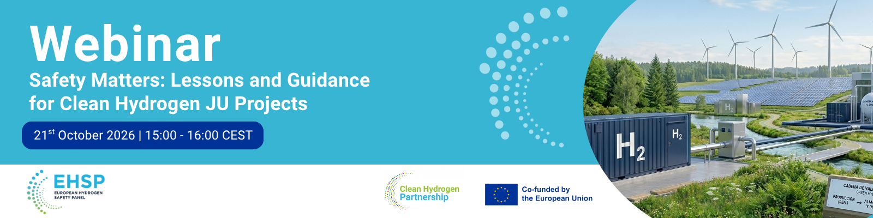
European Hydrogen Safety Panel
Safety Matters: Lessons and Guidance for Clean Hydrogen JU Projects
AGENDA
14:45 | Login, registration | SPEAKER
15:00 | Welcome and setting the scene | Mirela Atanasiu  (CLEAN HYDROGEN JU)
15:00 | Welcome and setting the scene | Beatriz Acosta Iborra  (Joint Research Centre)
15:10 | European Hydrogen Safety Panel (EHSP) –overview of the activities | Thomas Jordan  (Chair of the EHSP)
Focus Session: Support to Clean Hydrogen Partnership Projects
15:25 | Safety Plan and Guidance documents | Daniele Melideo  (Task 1 Leader)
Safety Plan as a living document: preparation, implementation, monitoring, reporting and regular updates.

Overview of project types and technology areas covered by the reviews.
Main recurring gaps and improvement areas identified in Safety Plans.

Aggregated results from recent EHSP Safety Plan reviews of Clean Hydrogen JU projects.

EHSP Safety Planning and Management guidance document: purpose, structure and key recommendations.

15:50 | Q&A
16:00 | End of the webinar

